Group: **Learners.**

Members:

1. Varun Parekh - AU2040011
2. Vanshit Shah - AU2040098
3. Madhvendra Jhala - AU2040162
4. Ushmay Patel - AU2040253

**Link of Google Colab:** <https://colab.research.google.com/drive/1FD8jJM55bxBIpSE9p5lCodCac_SeLHZN?usp=sharing>

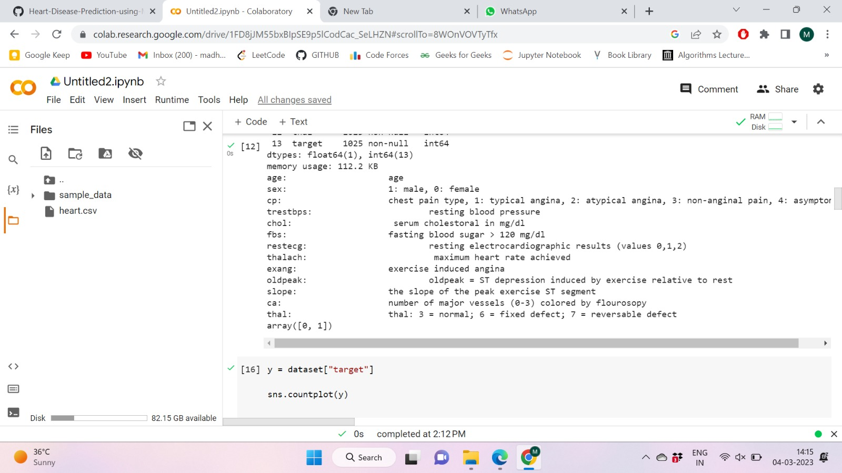

We have worked upon these parameters.

Age, sex, chest pain and its four types, resting blood pressure, cholesterol, fasting blood sugar, resting electrocardiographic results, maximum heart rate achieved , exercise induced angina, ST depression induced by exercise relative to rest, the slope of the peak exercise ST segment and the number of major vessels colored by fluoroscopy.

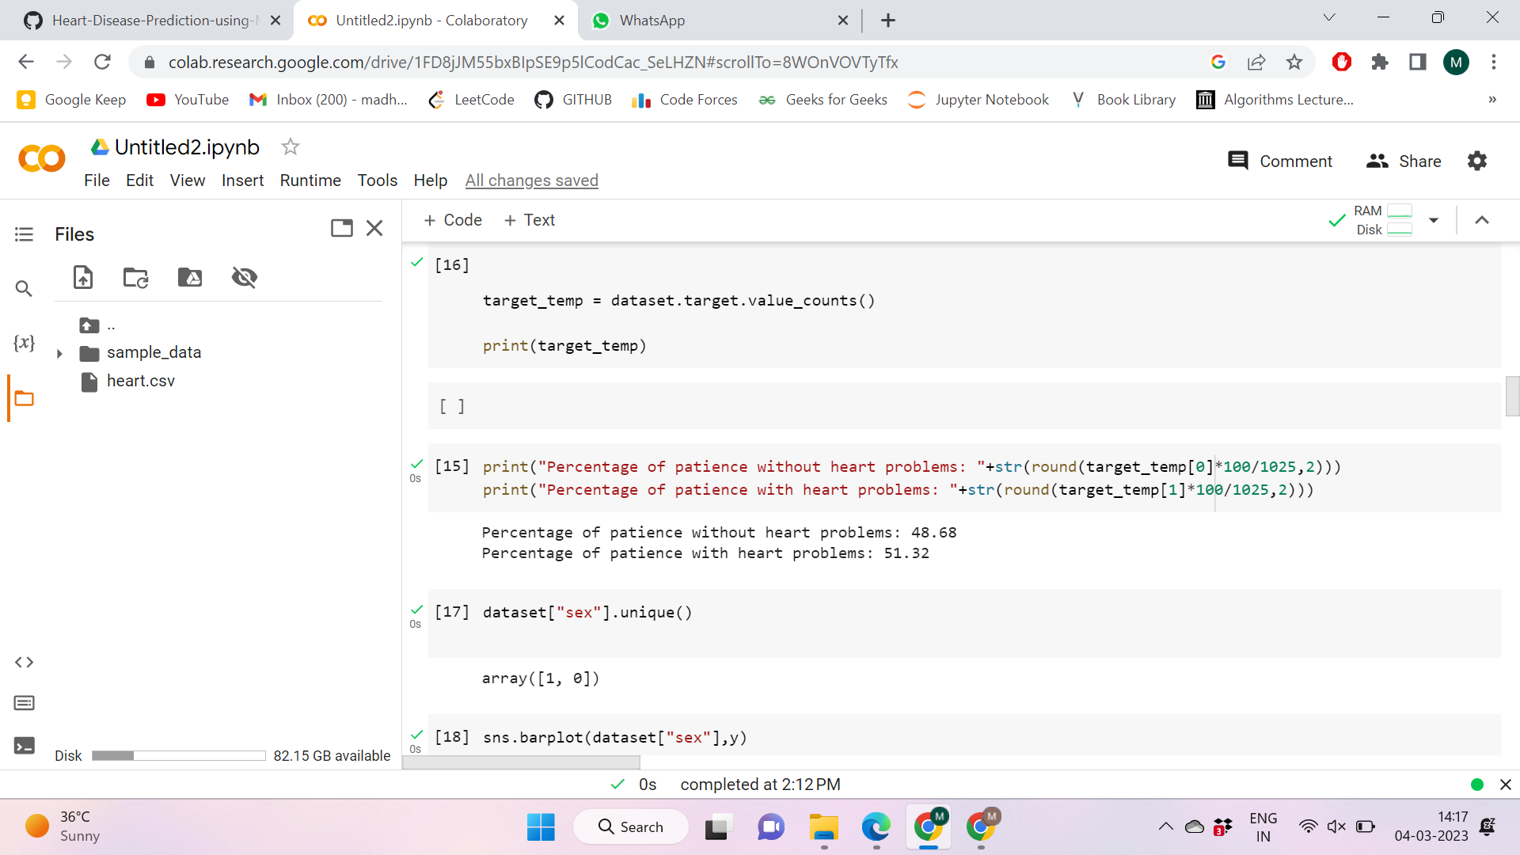

This shows the percentage of patients with and without heart problems.

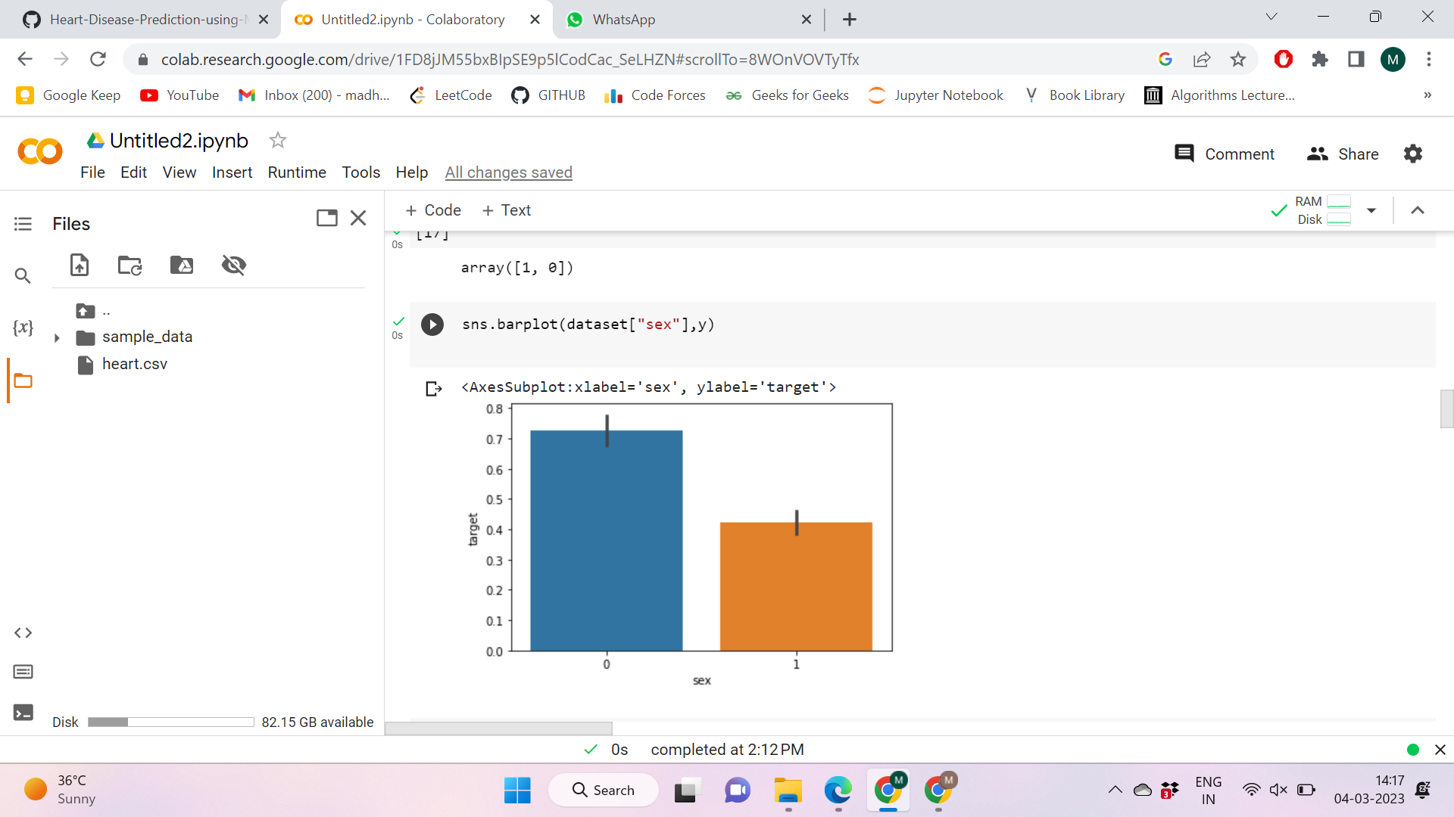

This denotes the sex percentage of our dataset.

(0→ female, 1→male)

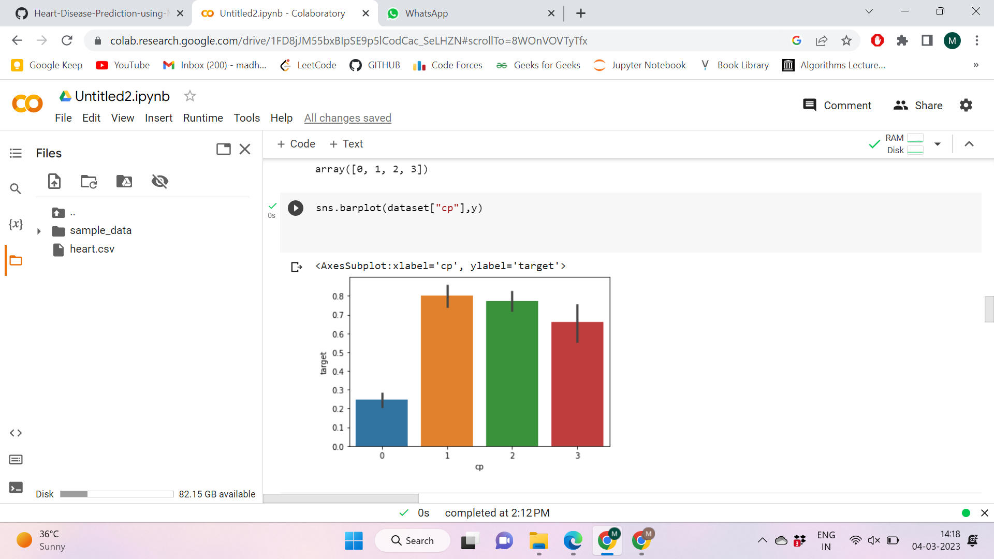

These are the 4 different types of chest pain.

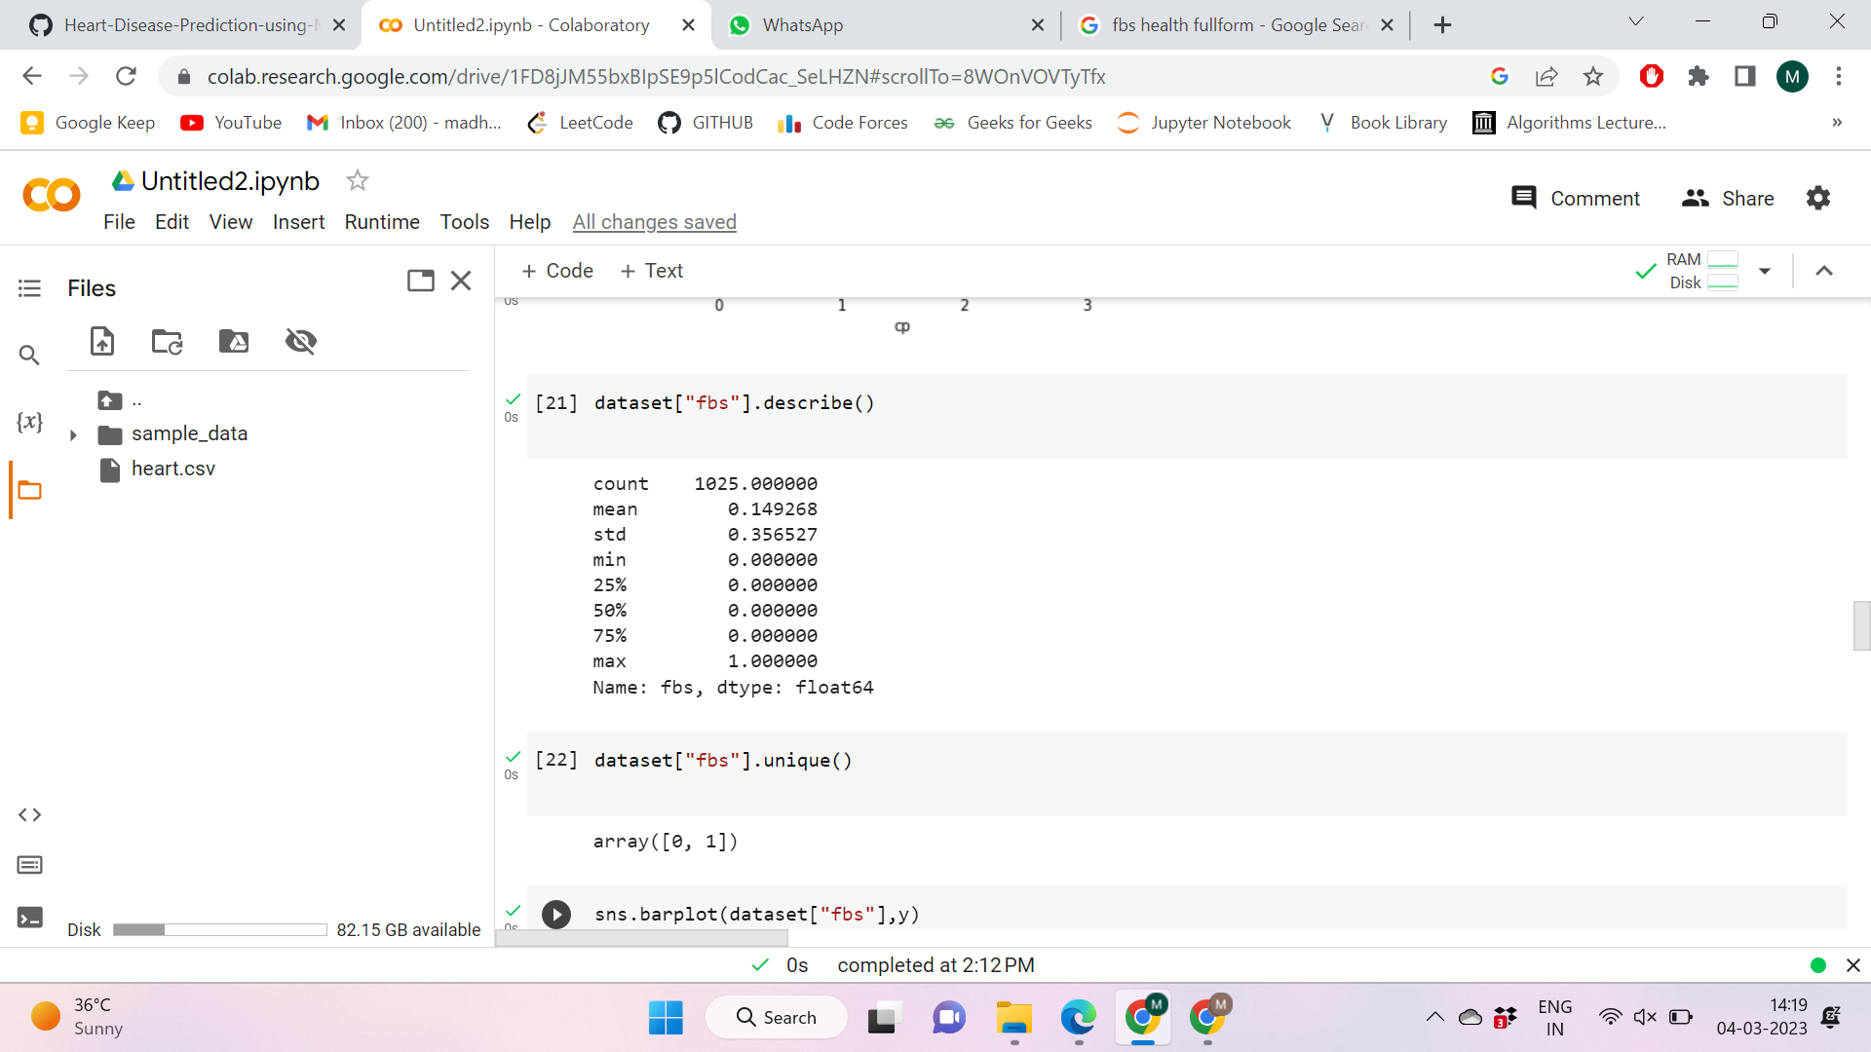

Fasting blood sugar

Summary of fasting blood sugar in our dataset.

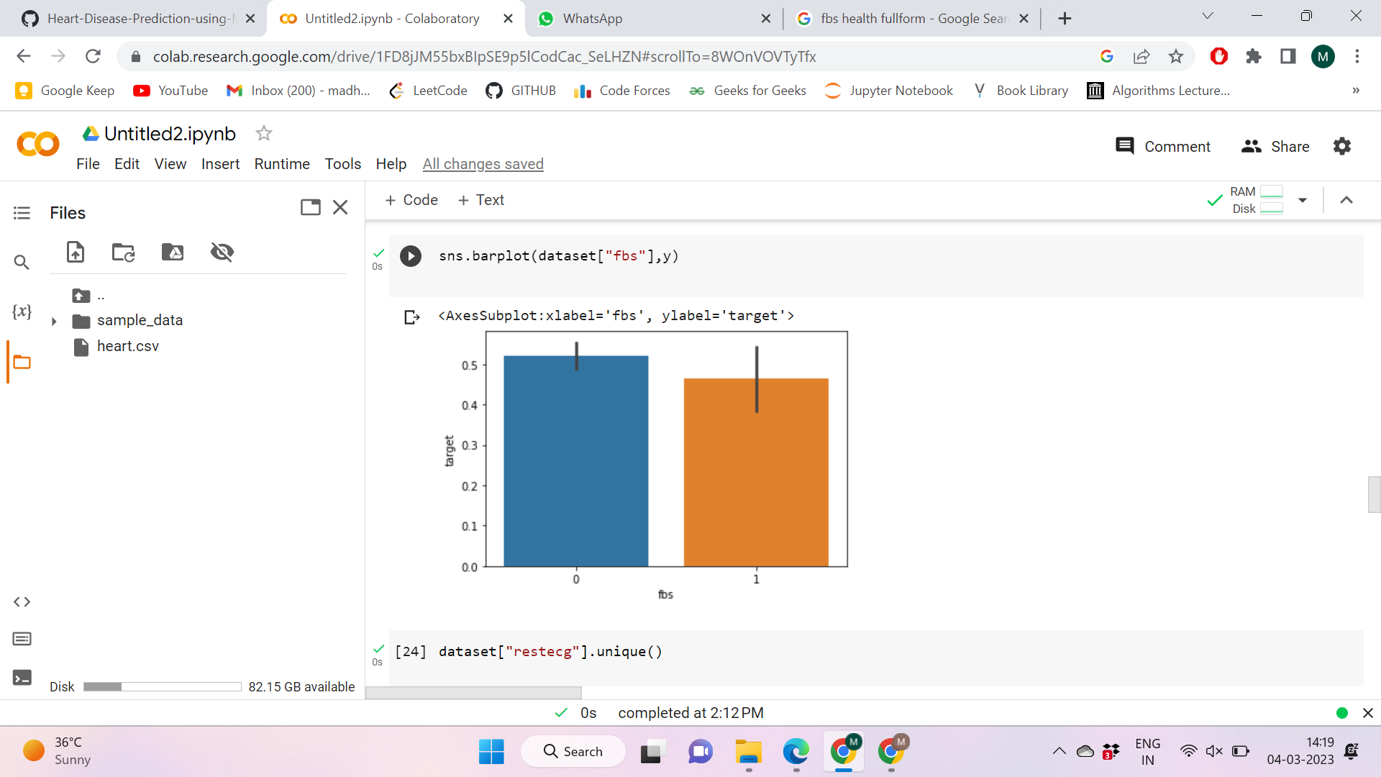

Fasting blood sugar result

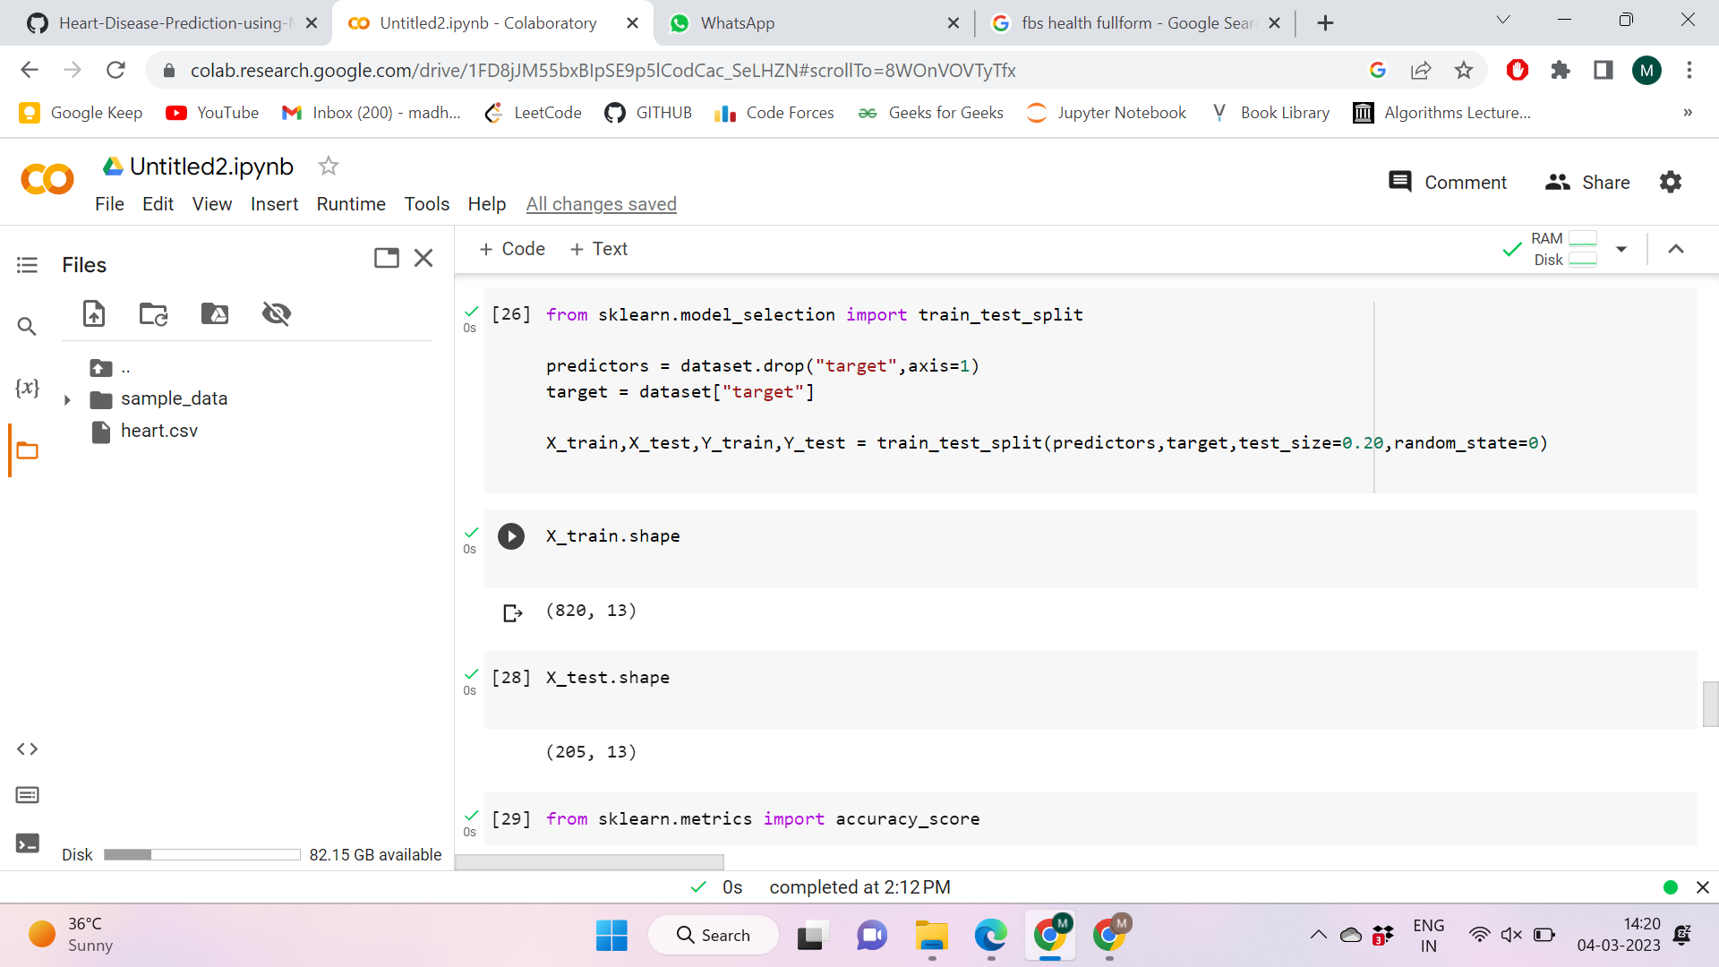

We have divided the data into 80% training set and 20% test set.

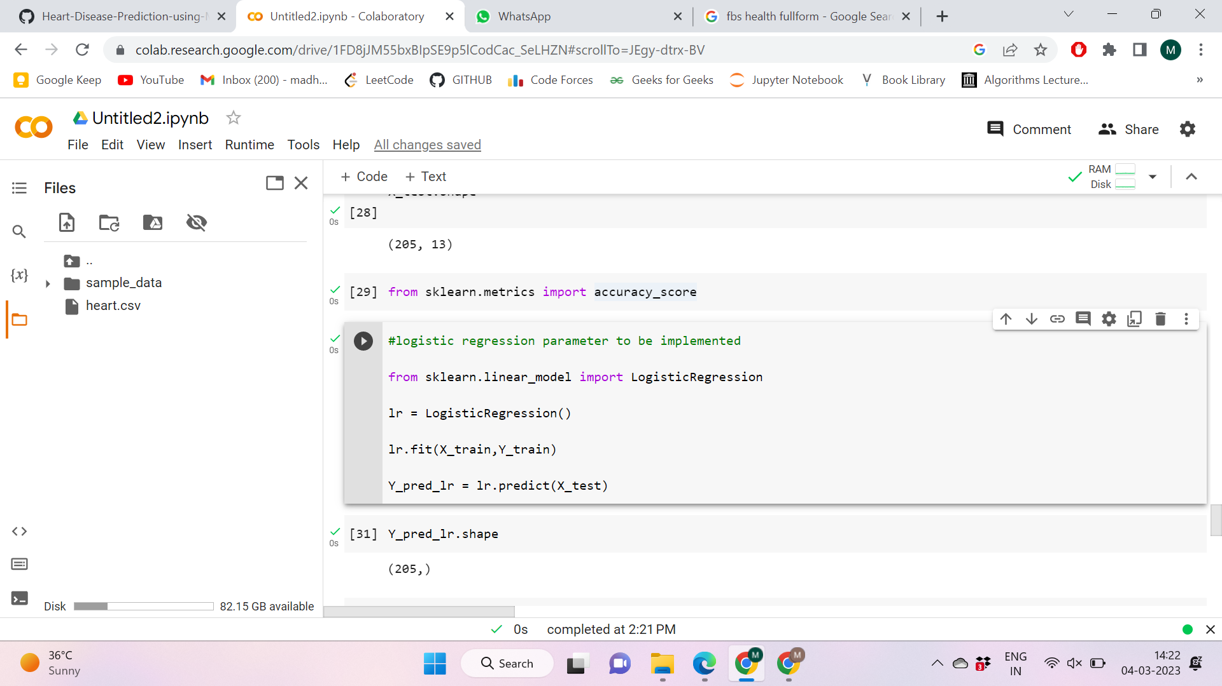

This is Logistic regression implementation.

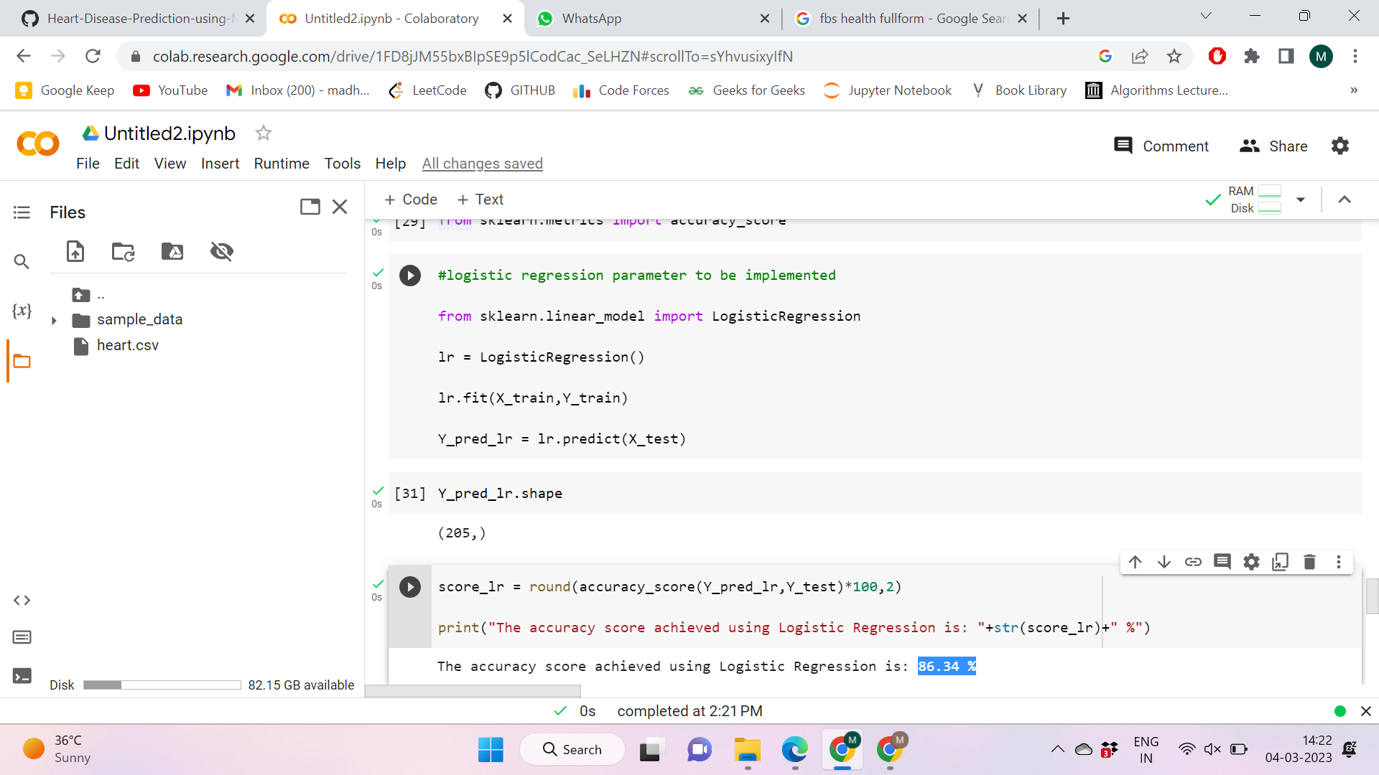

This is the accuracy achieved by logistic regression.

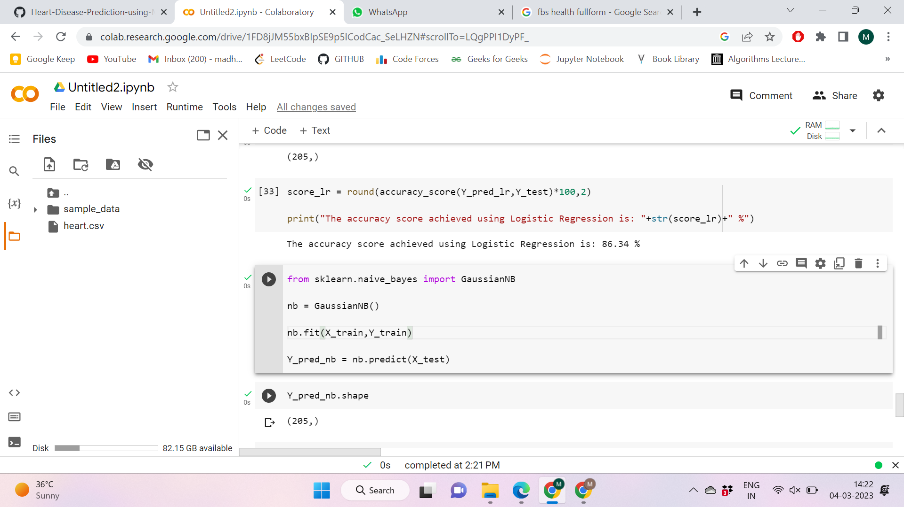

This is the naive bayes approach.

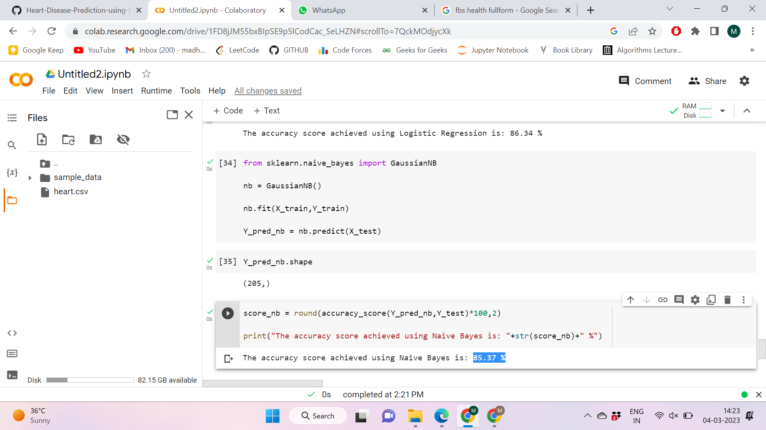

Accuracy of Naive Bayes approach.(85.37%)

//accuracy_score(to check predicted labels vs True labels)